Construction Planning Assistant Agent Report

  - Course Name: Agentic AI

Institution Name: Medi-caps University – Datagami Skill Based Course

Student Name(s) & Enrolment Number(s):
Sr no | Student Name | Enrolment Number
01 | Ansh Kumbhare | EN22CS301140
02 | Anshul Sen | EN22CS301158
03 | Anshul Yadav | EN22CS301159
04 | Armi Bhawsar | EN22CS301194
05 | Atharv Dubey | EN22CS301229

Group Name: 06D2
Project Number: AAI-18
Industry Mentor Name: Mr. Suraj Naik
University Mentor Name: Prof. Ajeet Singh Rajput
Academic Year: 2025-26

Problem Statement & Objectives

Problem Statement
Construction projects involve complex planning processes that require coordination between multiple tasks such as resource allocation, scheduling, permit acquisition, and risk management. Traditional planning methods are often manual, time-consuming, and prone to errors, leading to delays and cost overruns. There is a need for an intelligent system that can automate planning, break down high-level goals into actionable tasks, and optimize execution workflows.

Project Objectives
- To design and develop an intelligent Planner Agent for construction workflows
- To enable automatic decomposition of high-level goals into smaller actionable tasks
- To simulate real-world planning using multi-step reasoning
- To validate resources using mock tools and interfaces
- To generate structured and optimized execution schedules
- To improve efficiency, accuracy, and decision-making in construction planning

Scope of the Project
- Covers planning-level automation (not physical construction execution)
- Handles tasks like scheduling, permit planning, and workflow structuring
- Supports integration with APIs and simulated tools
- Can be extended for real-time construction management systems
- Useful for project managers, engineers, and planners

Limitations:
- Uses mock tools instead of real-time construction databases
- Limited real-world validation of resource availability
- Dependent on LLM accuracy (may produce occasional hallucinations)

- Does not handle dynamic on-site uncertainties in real-time
- Requires further integration for industry-level deployment

Proposed Solution
The proposed solution is a Construction Planning Assistant Agent, built using Agentic AI principles. The system takes a high-level construction goal (e.g., Permit Requirements) and processes it through a multi-step reasoning loop.
The agent:
- Understands the goal using an LLM
- Breaks it into sub-tasks
- Validates each step using tools (mock APIs)
- Organizes tasks logically
- Generates a complete execution schedule

- Key features
- Multi-step reasoning and task decomposition
- Autonomous planning and scheduling
- Tool-based validation system
- Modular and scalable design
- Human-readable structured outputs
- Integration with modern AI frameworks

- Overall Architecture / Workflow
Step-by-Step Workflow
- Input Stage
  - User provides a high-level goal (e.g., "Permit Requirements")
- LLM Processing
  - The language model interprets and understands the goal

- Task Decomposition
  - The agent breaks the goal into smaller actionable tasks
- Tool Interaction
  - Mock tools simulate:
    - Resource availability
    - Permit validation
    - Timeline estimation
- Reasoning Loop
  - The agent iteratively refines tasks using reasoning
- Schedule Generation
  - Outputs a structured plan with timelines and dependencies
- Final Output
  - A detailed execution roadmap

- Tools & Technologies Used
- Programming Language: Python
- Frameworks: LangChain / CrewAI
- LLM API: Grok AI / OpenAI APIs
- Environment: Jupyter Notebook / VS Code
- Other Tools:
- Mock APIs for simulation
- Prompt engineering techniques

Results & Output
- Screenshots / outputs
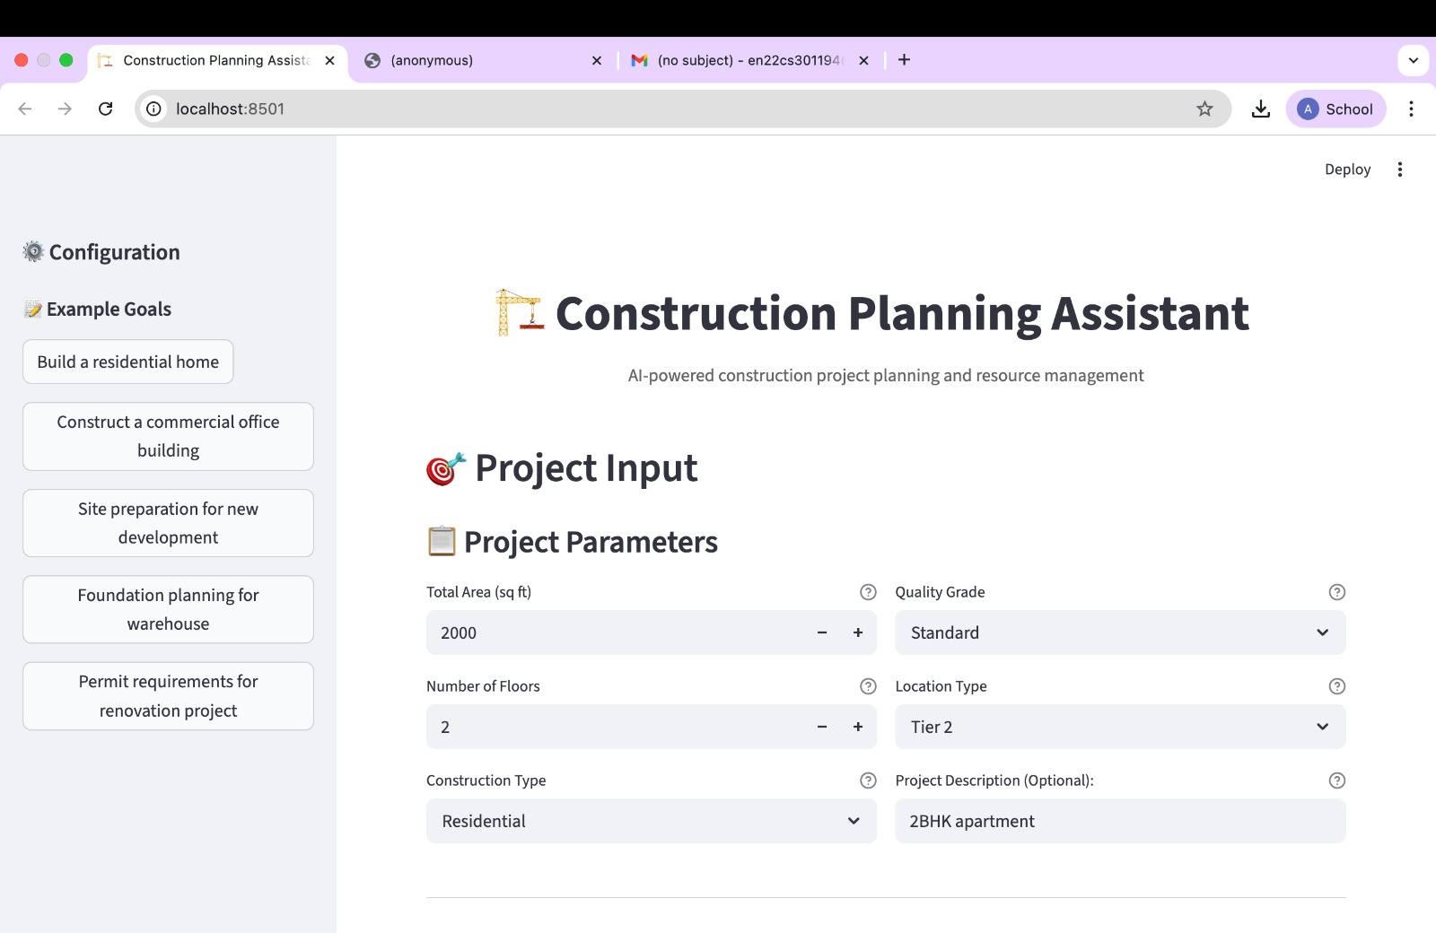
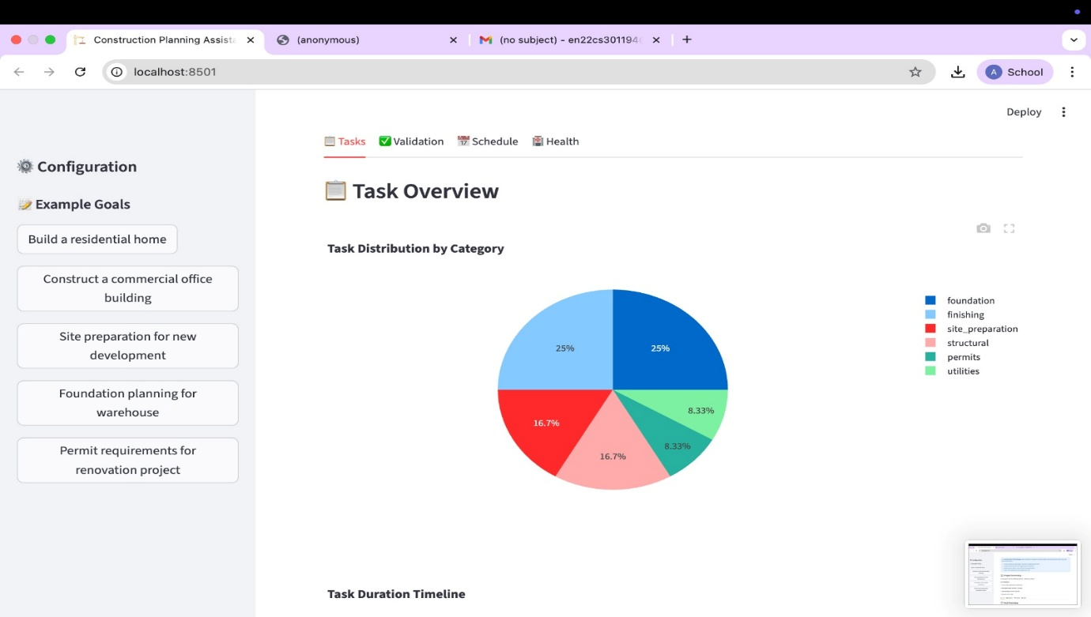

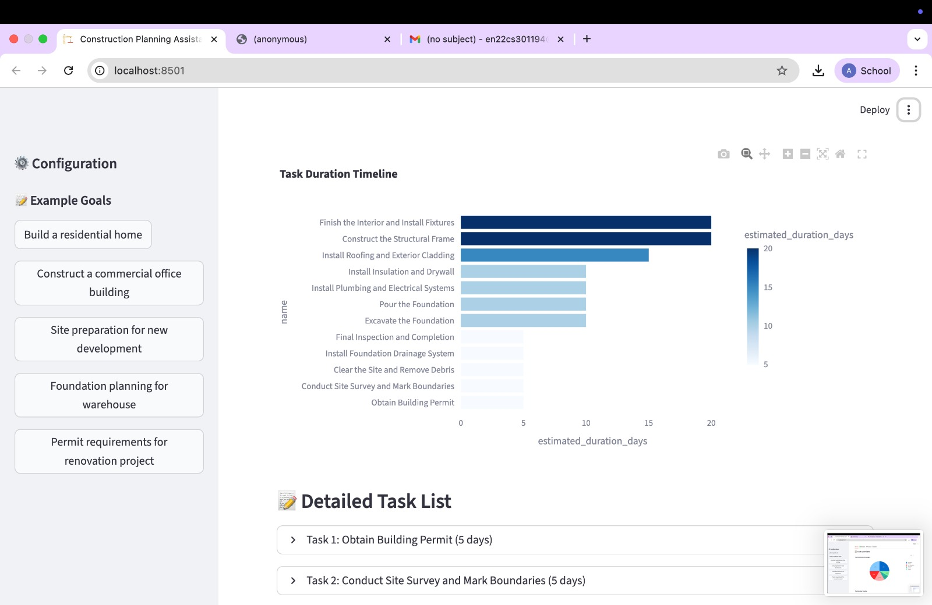

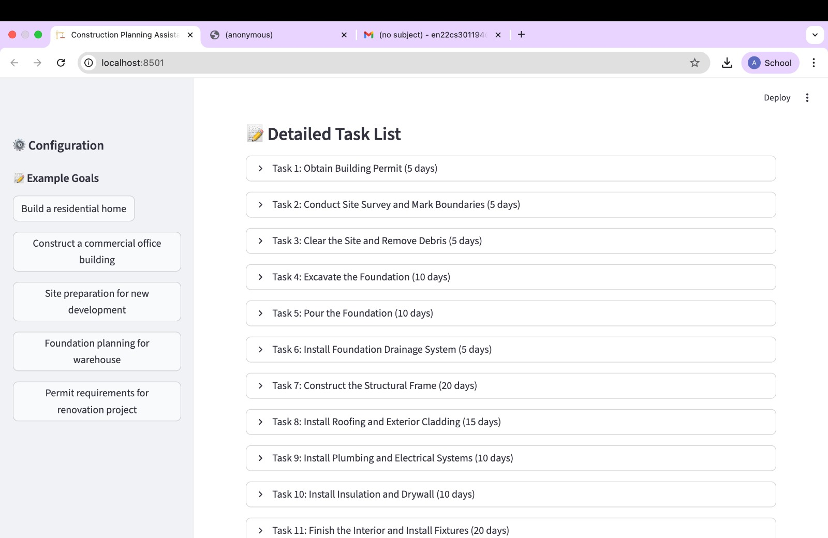

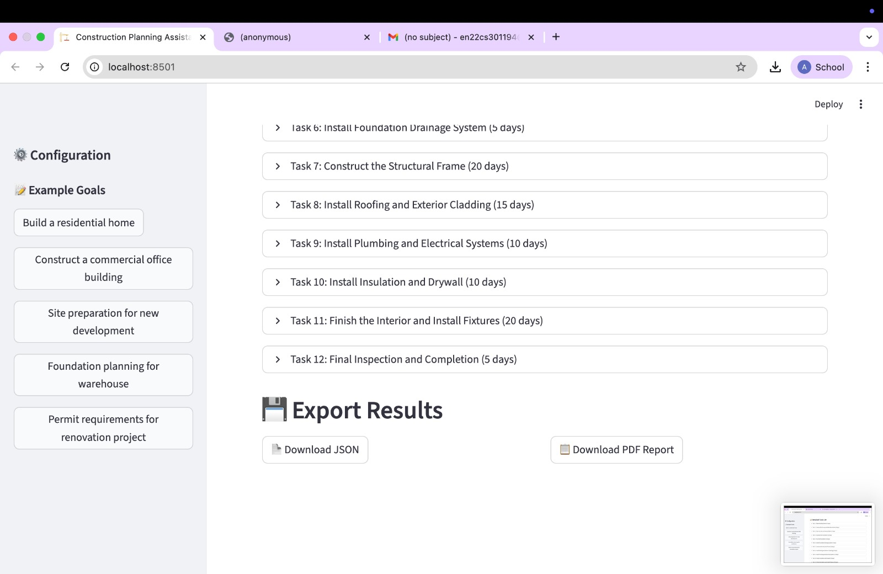

- Input: High-level construction goal
- Output:
- Task breakdown
- Resource validation
- Execution schedule

- Reports / dashboards / models
- Structured planning reports generated automatically
- Task dependency mapping
- Timeline-based execution plans

- Key outcomes
- Successfully built a working prototype of a Planner Agent
- Automated construction planning workflow
- Reduced manual effort in task breakdown
- Demonstrated practical use of Agentic AI
- Improved understanding of multi-agent reasoning systems

Conclusion
The Construction Planning Assistant Agent demonstrates how Agentic AI can transform traditional planning processes in construction. By automating task decomposition, validating resources, and generating structured execution plans, the system enhances efficiency and reduces human error. This project highlights the potential of integrating LLMs with planning systems to create intelligent, scalable solutions for complex real-world problems.

Future Scope & Enhancements
- Integration with real-time construction databases and APIs
- Addition of cost estimation and budgeting modules
- Real-time monitoring and adaptive planning
- Multi-agent collaboration (e.g., safety agent, cost agent)
- Deployment as a web or mobile application
- Integration with BIM (Building Information Modelling) systems

